Lab 1 – VM Setup
- In the newly set up VM, what does the $HOME environment variable represent?
The $HOME environment variable represents the path of the home directory of the current user.

- What does sudo mean in a Unix/Linux environment, and when is it typically used?
The sudo command switches to the shell allow to run command with root privilege. When using sudo <command>, it executes the <command> with root privilege.

- Write and briefly explain and 6 Unix/Linux commands. Execute each command in the terminal of the new VM and paste screenshots of the output.

Command cd: go to specific path. When type cd, it will go to home directory.
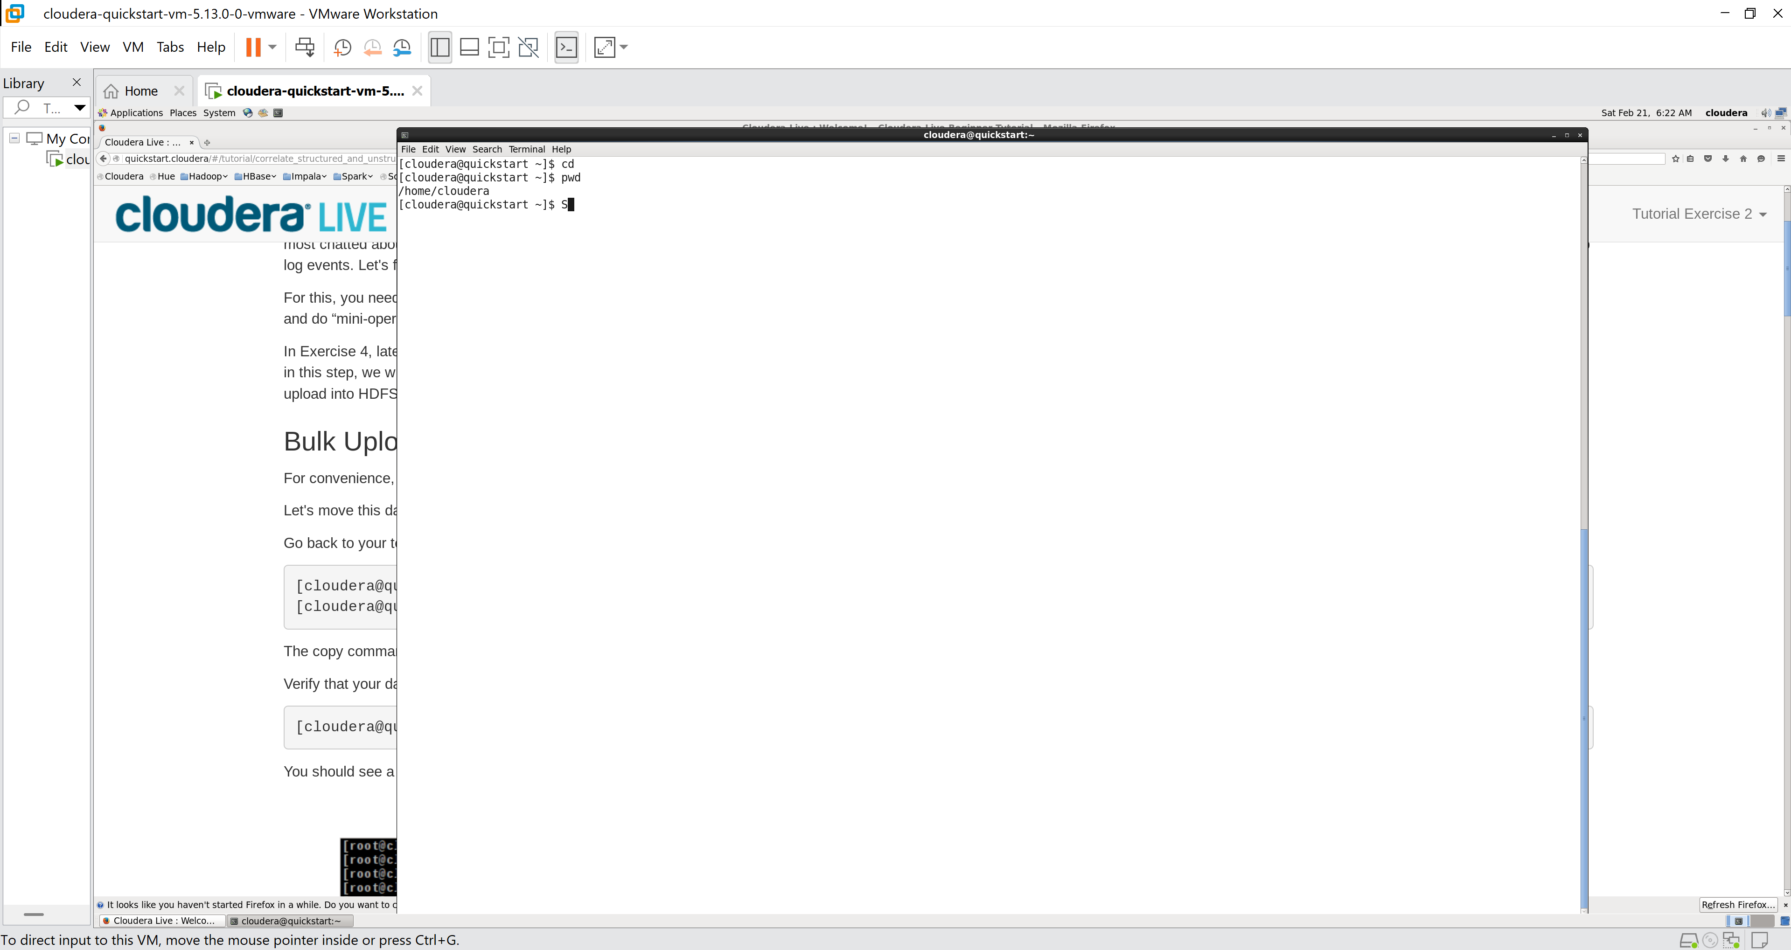

Command touch: change the file timestamps to current time. I may be used to create new file
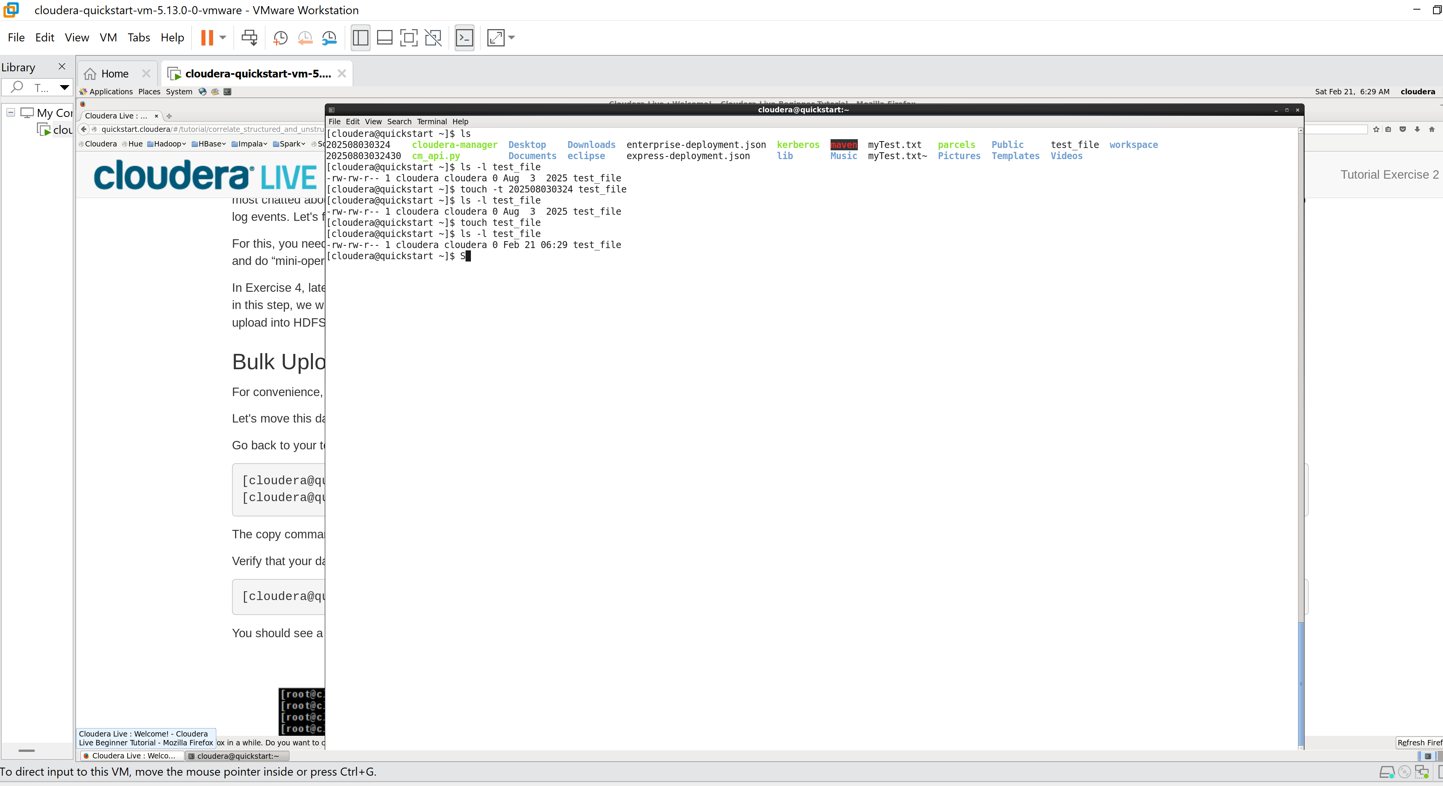

Command mkdir: to create new directory
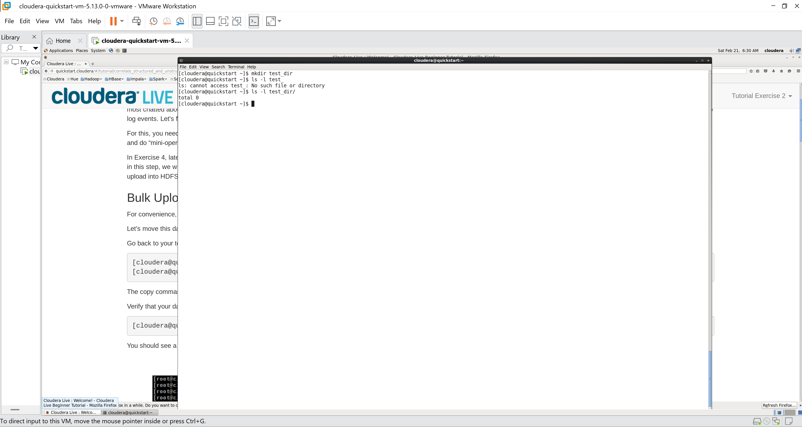

Command rm: remove directory
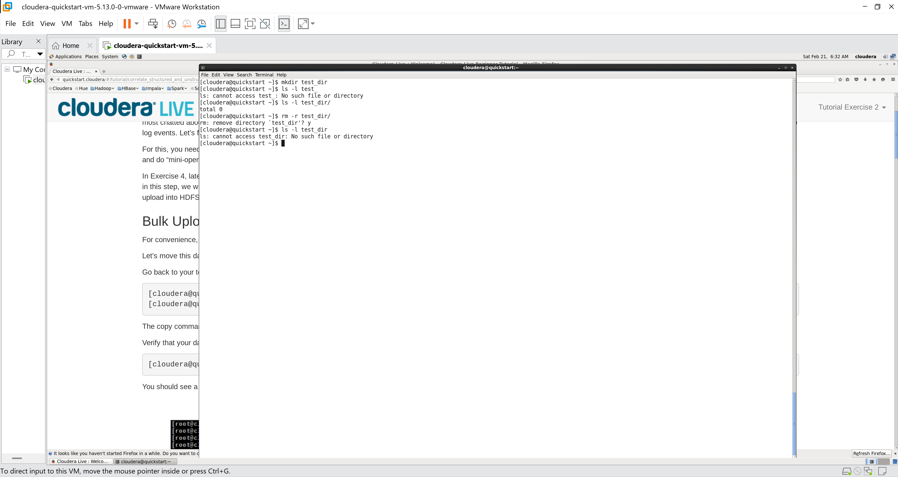

Command ls: list directory or file
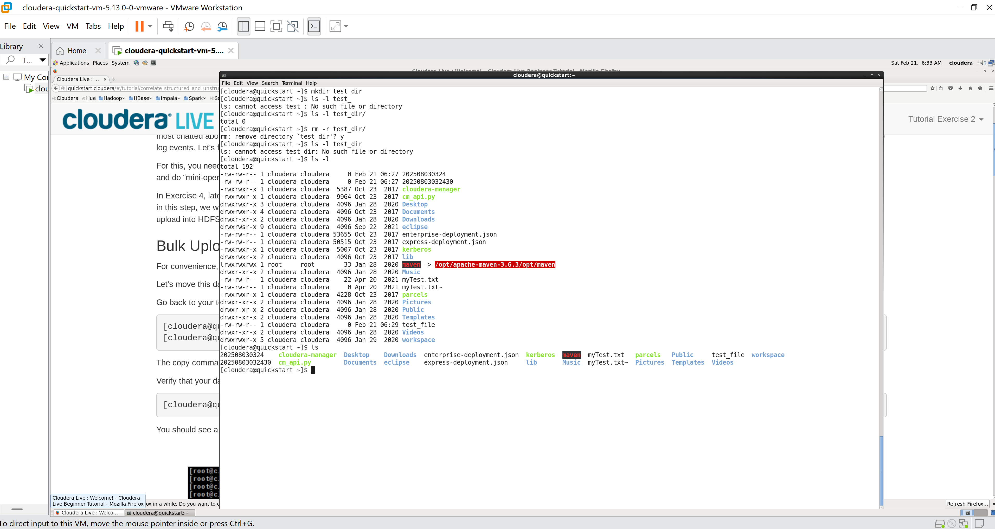

Command pwd: display current directory
